**Problem No: 01**

**Topic: Basic Structures: Sequences and Sum**

**Problem Title:**

Find the value of the following series: $1+ \frac{1}{2}+\frac{1}{4}+ \frac{1}{8}+ \frac{1}{16}……. ….$

**Objectives:**

To calculate the value of a series.

**Source Code:**

#include <iostream>

using namespace std;

int main()

{

double sum = 1;

int i = 1, n = 1;

cout << 1;

n++;

while(n){

sum += 1.0 / (i * 2.0);

i *= 2;

if(i == 0)

break;

cout << " + (1 / " << (i * 2.0) << ") ";

}

cout << "\n\nValue of the Series: " << sum << endl;

return 0;

}

**Output:**

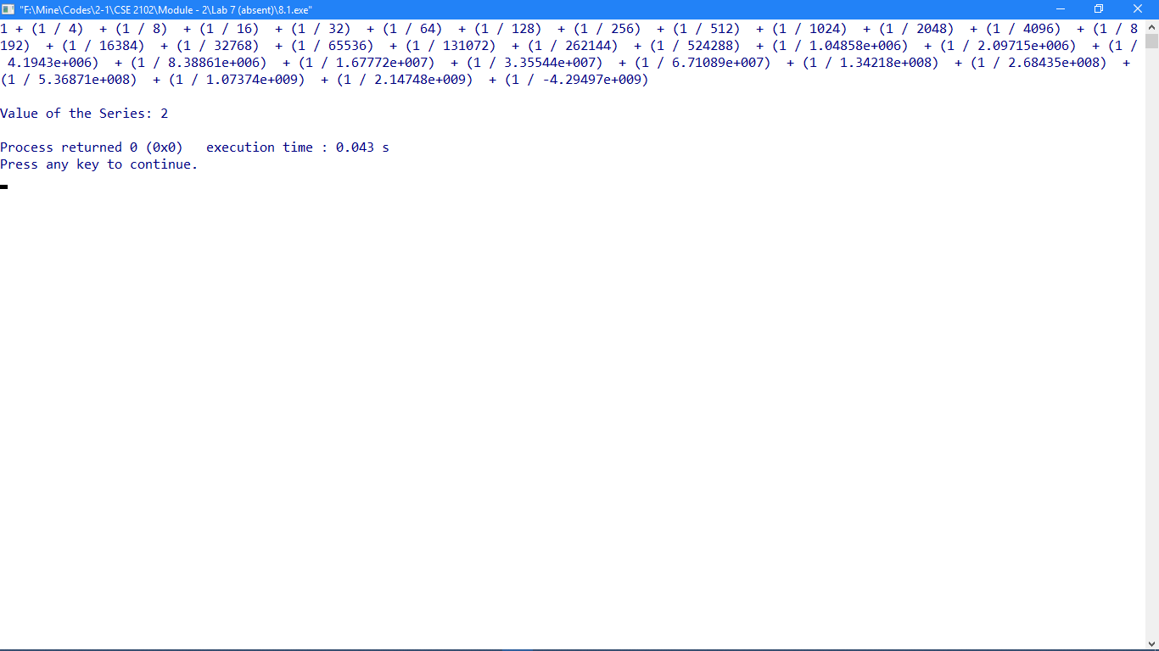

**Problem No: 02**

**Topic: Basic Structures: Sequences and Sum**

**Problem Title:**

Calculate the value of Pi (π).

**Objectives:**

To learn the methods of how to calculate Pi.

**Theory:**

**The Gregory-Leibniz Series:**

$$π=4 \sum_{n=1}^{∞}{\frac{{(-1)}^{n}}{\left(2n+1\right)}}$$

**Machine’s Formula:**

$$π=16 \tan^{-1}{\frac{1}{5}}-4 \tan^{-1}{\frac{1}{239}}$$

$$\tan^{-1}{x}=x-{\frac{x}{3}}^{3}+ {\frac{x}{5}}^{5}- {\frac{x}{7}}^{7}+…$$

**Source Code:**

#include<iostream>

#include<cmath>

using namespace std;

void GL();

void M();

int main()

{

GL();

M();

return 0;

}

void GL()

{

double s = 0, d, i;

for(i = 0; i <= 10000; i++){

d = pow(-1, i) / (2 * i + 1);

s+= d;

}

s *= 4;

cout << "Gregory-Leibniz series, PI = " << s << endl;

}

void M()

{

double s1 = 0, s2 = 0, k=1, d1, d2, a = 1.0 / 5.0, b = 1.0 / 239.0, pi;

int i;

for(i = 1; i <= 10000; i++){

d1 = pow(a,k) / k;

d2 = pow(b,k) / k;

if(i%2==1){

s1 += d1;

s2 += d2;

}

else{

s1 -= d1;

s2 -= d2;

}

k += 2;

}

pi = 16 * s1 - 4 * s2;

cout << "Machine's formula, PI = " << pi << endl;

}

**Output:**

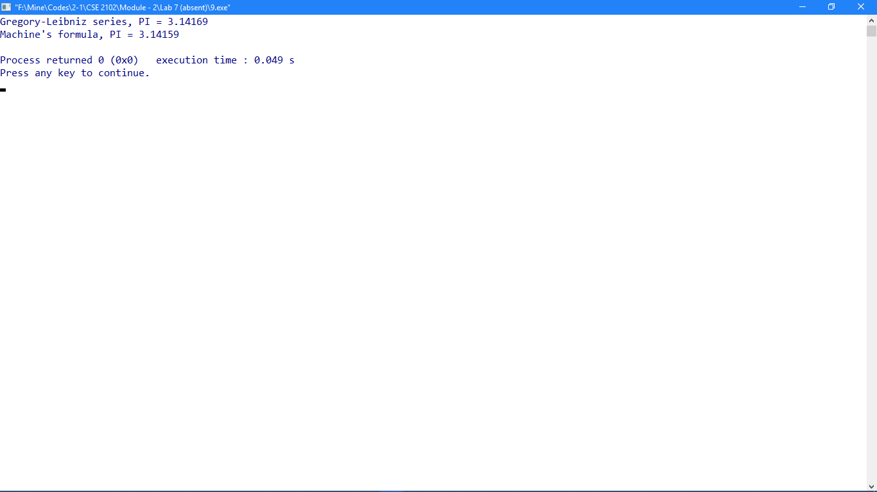

**Problem No: 03**

**Topic: Basic Structures: Sequences and Sum**

**Problem Title:**

Calculate the value of golden ratio.

**Objectives:**

To learn about Golden Ratio.

**Theory:**

**Golden Ratio:**

$$\frac{a}{b}= \frac{a+b}{a}$$

$$1+ \frac{b}{a}=1+ \frac{1}{\frac{a}{b}}= φ$$

$$φ=1+ \frac{1}{φ}$$

$$φ^{2} - φ-1=0$$

Solving this equation,

$φ=1.$ 61803

**Golden Ratio: 1.61803:1**

**Source Code:**

#include <iostream>

#include <cmath>

using namespace std;

int main()

{

cout << "Equation of Golden Ratio: x^2 - x - 1 = 0\n";

int a = 1, b = -1, c = -1;

double x;

x = (- b + sqrt((b * b - 4 * a * c))) / (2.0 * a);

cout << "Golden Ratio: " << x << " : 1 "<< endl;

return 0;

}

**Output:**

